Administrative Gating as a Decision-Centric Degree of DTC Implementation
Francis Amojelar
Faculty of Business, Athabasca University, Canada · [famojelar1@learn.athabascau.ca

Abstract
Digital Twin Construction (DTC) research has established a decision-centric design approach: define the target managerial decision, trace it backward through knowledge and information requirements to the minimal data and technology needed to close a Plan-Do-Check-Act (PDCA) loop [1]. Existing field-validated implementations of this approach achieve automated or semi-automated conformance evaluation primarily through sensor-based reality capture or simulation-based data fusion, corresponding to Degree 3 (Digital Shadow) or higher among the five degrees of DTC implementation [1]. This paper applies the same decision-centric design methodology to a distinct and lower-cost class of managerial decisions: gating construction tasks on the verified status of administrative records (document reviews, inspection results, and task completion) rather than on continuously sensed physical state or simulated projections. We show that three field-sourced failure incidents — a $1,500 design rework caused by an unreviewed geotechnical report, a material delivery executed against an unready foundation, and an inspection failure whose downstream blocking effect was tracked only informally — can each be formalized as a decision-centric gating specification requiring no reality capture, no data fusion, and no simulation infrastructure, while still achieving the automated conformance evaluation characteristic of Degree 3 implementations. We term this configuration an administrative digital shadow and argue it exposes a boundary case in the existing degree definitions: the Digital Shadow definition bundles automated conformance evaluation (a capability) with multi-source data fusion (a mechanism), yet for this decision class the capability is achievable with neither fusion nor the instrumentation or modeling cost the framework’s existing examples require.

Keywords
Digital Twin Construction; Decision-centric System Design; Administrative Gating; Plan-Do-Check-Act; Knowledge-Information-Data; Dependency Validation

1 Introduction
Building construction projects require short-cycle PDCA loops to detect deviations between intent and status early enough that corrective action remains possible [2,3]. Recent work has reframed Digital Twin Construction (DTC) system design around this requirement directly: rather than letting the available sensing and analytics stack dictate what gets built, a decision-centric approach takes the target managerial decision and its PDCA cycle as the point of departure, then traces backward through knowledge and information requirements to the minimal sufficient data and enabling technology [1]. This “thinking backward” method is explicitly intended to prevent over-engineering: the system specified is only as large as the target decision, at its required cadence, demands.
Applied to field-validated case studies, this approach has so far been demonstrated on decisions requiring physical-state monitoring or simulation-based data fusion: concreting crew task assignment via formwork sensing [4], tunnelling bracketry design via TBM and manufacturing data fusion [5], both reaching Degree 3 via automated reality capture, and adaptive production system design via ontology-based agent simulation [6], reaching between Degrees 3 and 4 via data fusion without reality capture but with dedicated simulation infrastructure. None of the three relies on purely administrative, document- or status-based data alone.
This paper asks whether the same decision-centric methodology, applied to a different class of managerial decision, can achieve automated conformance evaluation without reality capture. We examine decisions in which the relevant “status” is not a continuously sensed physical quantity (curing temperature, structural alignment) but a discrete, human-recorded administrative fact: whether a document has been reviewed, whether an inspection passed, whether a prerequisite task is complete. We term the resulting system class an administrative gating layer and present three field-sourced incidents, formalized using the same decision axes and implementation-degree framework proposed in [1], to argue this class occupies a distinct and previously unnamed position in the DTC implementation space: automated, Degree-3-equivalent conformance evaluation achieved through zero-sensor, document- and status-based data alone.

2 State of the Art

2.1 Digital Twin Construction and Decision-Centric Design
Sacks et al. [2] introduced DTC as a data-centric construction management paradigm that continuously compares project intent information (as-designed product, as-planned process) with project status information (as-built product, as-performed process) to generate conformance evaluations and support PDCA cycles. Yeung and Sacks [1] extend this with a decision-centric design methodology, characterizing managerial decisions along three axes — autonomy (from human decide, through human decide with machine advice and machine decide with human supervision, to machine decide), fidelity (temporal resolution, update frequency, accuracy), and scope (localized/global, single/coupled decisions) — and proposing five degrees of DTC implementation: unassisted, digital model, digital shadow, supportive digital twin, and autonomous digital twin, framed as coherent capability bundles rather than a strict linear maturity ladder. Of the three field-validated case studies classified in [1], two [4,5] reach Degree 3 (Digital Shadow) via automated reality capture and data fusion from sensors; the third, the authors’ own prior work [6], reaches between Degree 3 and 4 via agent-based simulation and data fusion of existing project data, without reality capture. This already indicates that reality capture is not strictly required to reach Degree 3-equivalent capability, though [6] still depends on simulation infrastructure absent in the cases examined in this paper.

2.2 Ontology-Based Data Integration
A parallel line of work addresses DTC’s data-layer requirements through semantic web technology. Schlenger et al. [7] propose a plug-in-based reference architecture coupling multiple RDF graphs with a Digital Twin Construction Ontology (DTC-O) that formally separates project intent from project status, validated against the ConSLAM dataset. Zheng et al. [8] propose a complementary ontology-network framework for construction workflow monitoring. Both approaches require RDF/OWL tooling, SHACL or equivalent constraint validation, and ontology engineering expertise to operate or extend — a materially different operability profile from the field-deployed sensor-based systems in Section 2.1.

2.3 Enterprise-Scale Data Unification
Outside academic DTC research, enterprise data platforms address a related but distinct problem: unifying fragmented organizational data sources into a queryable “single source of truth.” Palantir’s Foundry Ontology models objects, links, and actions atop integrated enterprise data at large scale [9]. At least one major Canadian general contractor has built a comparable internal platform, publicly described by its architect as solving data visibility and accessibility rather than automated decision gating [10]. This distinction — visibility versus enforcement — motivates the present paper’s focus on gating specifically, rather than data consolidation generally.

3 Applying Decision-Centric Design to Administrative Gating
Following the methodology of [1], we define the target decisions, then trace requirements downward through knowledge, information, and data.

3.1 Target Decisions
Three managerial decisions, each drawn from a real field incident reported by construction PMs during an applied AI training cohort:
D1 — Whether downstream finishing work (drywall) may begin, given upstream trade rough-in and inspection status.
D2 — Whether structural design may proceed, given the review status of a prerequisite geotechnical report.
D3 — Whether a scheduled material delivery should proceed, given the completion status of the task it depends on (foundation erection).

3.2 Knowledge, Information, and Data Trace
For all three decisions, the required knowledge is conformance of a specific administrative record’s status against a required value (inspection result = passed; document reviewed = true; task status = complete) — not an inferred physical state. The required information is therefore a single discrete status field per prerequisite record, plus a declared dependency edge linking it to the downstream decision. The required data is the administrative record itself: an inspection report, a document review confirmation, a task completion update — each already generated as a byproduct of existing project processes, requiring no new sensing, scanning, or monitoring infrastructure to capture.
This is the central contrast with the case studies in [1]: where those systems trace from decision to physical sensing requirements (distance sensing, temperature sensing, imagery), the administrative gating trace terminates at data already produced by normal project administration. The remaining system requirement is not data acquisition but data structuring and dependency enforcement — a schema (Type registry, relationship vocabulary) and a constraint validator, described in Section 4.
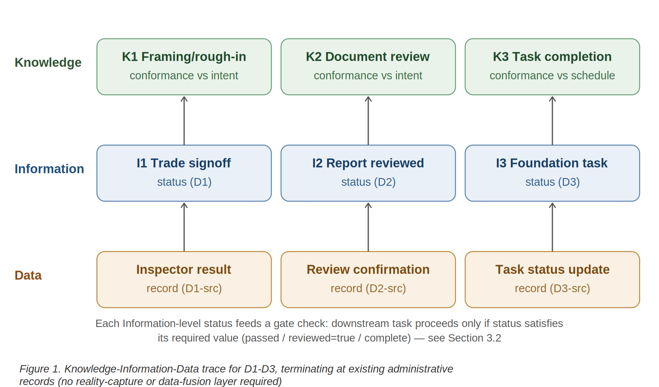

3.3 Decision Characterization
Using the autonomy/fidelity/scope axes from [1]:
Autonomy — All three decisions fall in the human decide with machine advice class: a human establishes the underlying fact (an inspector’s pass/fail judgment, a reviewer’s confirmation), and the system automatically determines and advises whether dependent work may proceed given the recorded status. The system does not decide whether the geotech report is adequate; it advises on the release decision that depends on that fact.
Fidelity — Temporal resolution is event-driven rather than continuous: status changes on discrete events (an inspection occurring, a document being marked reviewed), not on a fixed sampling interval. Required accuracy is high, but trivially so, since the underlying values are binary or small enumerations rather than continuous measurements requiring calibration.
Scope — Each decision is individually small and localized, but D1 and D3 exhibit coupling: a single upstream status change (an inspection failure, a foundation status) cascades to block a specific downstream task, matching the “creates dependencies and cascading effects” scope characterization in [1].

4 Case Study: Zone 3 Reference Implementation
A reference project structure was populated with real field data implementing D1–D3 as an explicit dependency graph. Records are plain-text files conforming to a declared Type registry (13 ratified record types, including compliance-evidence, site-investigation-report, design-task, and material-delivery), each file representing exactly one record instance, linked through a controlled relationship vocabulary whose edge types carry gating semantics: blocks (predecessor must complete), requires-signoff-from (target compliance-evidence record must carry result = passed), and requires-input-from (referenced document must exist and carry a reviewed status with a named reviewer — existence alone does not satisfy the edge, which is precisely the distinction that failed in incident D2). The populated structure comprises 34 typed records and a dependency graph of 11 task nodes and 9 edges within a declared three-level spatial hierarchy, with Zone 3 fully populated. A constraint checker, analogous in purpose to SHACL shape validation but operating directly on the plain-text structure, performs five checks on every run: required-field and enumerated-value conformance against the Type registry, status-vocabulary conformance, resolution of every dependency reference to an existing task, cycle detection over the dependency graph, and resolution of every zone reference to a node declared in the spatial hierarchy. Gating is then a deterministic traversal: a task is releasable if and only if every upstream record on its dependency chain carries the required status value. The full validation run completes in under 0.1 seconds on commodity hardware, with no server, database, or network dependency. The validator and the reference structure are available at github.com/ciscel/project_management_okf.
Table 1 classifies the three decisions using the same framework and table structure as [1] Table 1, for direct comparison against the field-validated Digital Shadow case studies it reports.
Table 1. Classification of administrative gating decisions D1–D3
 | D1 | D2 | D3
Use Case | Downstream finishing-task release gated on trade rough-in inspection status | Design-task start gated on prerequisite document review status | Material delivery release gated on dependent task completion status
Autonomy | Human decide with machine advice | Human decide with machine advice | Human decide with machine advice
Fidelity Temporal Resolution | Event-driven | Event-driven | Event-driven / Daily
Update Frequency | On event | On event | Daily
Accuracy | High | High | High
Scope | Medium, coupled | Medium, coupled | Medium, coupled
Reality Capture | No | No | No
Data Fusion and Interpretation | No | No | No
Conformance Evaluation | Yes, automated | Yes, automated | Yes, automated
Simulation/Optimization | No | No | No
Recommendation | Yes, identifies blocking trade and reinspection date | Yes, blocks design start pending review confirmation | Yes, holds delivery pending status
Report & Visualization | Yes, dependency chain display | Yes, dependency chain display | Yes, dependency chain display
Rule-based Assistance | Yes | Yes | Yes
Directive Tool | No | No | No
Degree of DTC Implementation | Degree-3-equivalent conformance capability – administrative digital shadow (no reality capture, no fusion) | Degree-3-equivalent conformance capability – administrative digital shadow (no reality capture, no fusion) | Degree-3-equivalent conformance capability – administrative digital shadow (no reality capture, no fusion)

Two results are notable. First, all three decisions achieve “Yes, automated” conformance evaluation — the same capability that places the sensor-based case studies in [4,5] at Degree 3 — without automated reality capture or data fusion. Second, each decision’s real-world incident (Section 3.1) represents a case where this automated evaluation did not exist in the deployed project systems, and where its absence produced a specific, quantified cost: $1,500 in avoidable design rework for D2, material remobilization cost for D3, and an informally-tracked (rather than systematically traceable) blocking cause for D1.

5 Discussion
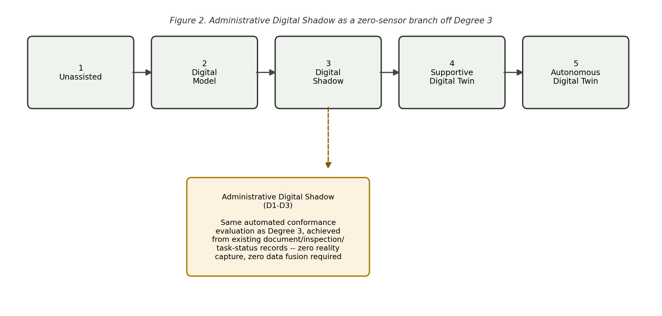
The classification in Table 1 surfaces a definitional tension in the degrees of implementation proposed in [1]. The degrees are presented there explicitly as coherent capability bundles rather than a strict linear maturity ladder, and we take that framing at face value. The tension lies within the Digital Shadow definition itself: Degree 3 is defined by the integration of multiple data sources through explicit interpretation and data fusion to produce consolidated project status information — that is, the definition bundles a capability (automated conformance evaluation) with a mechanism (multi-source data fusion). By that definition as written, the configuration examined in this paper does not qualify as Degree 3: it performs no fusion and no interpretation of raw observations. Yet it achieves, fully automatically, the specific capability that distinguishes the Degree 3 case studies [4,5] — systematic comparison of intent to status supporting a bounded PDCA loop — using only structured administrative records that already exist as a byproduct of standard project management practice. Notably, no configuration in [1] Table 1 occupies this position: [4] and [5] reach automated conformance evaluation through automated reality capture and fusion, while [6] operates without reality capture but retains automated data fusion and achieves only semi-automated conformance evaluation. Fully automated conformance evaluation with neither reality capture nor data fusion is, on that evidence, an unoccupied configuration — one the Degree 3 definition, as currently worded, cannot name. We therefore argue the definition conflates capability with mechanism, and that the coupling of “automated conformance evaluation” to sensing-and-fusion investment persists in the definition even though the framework’s non-linear framing disclaims it.
We propose this be recognized as a distinct sub-case rather than a lesser approximation of Digital Shadow: an administrative digital shadow, characterized by automated conformance evaluation over discrete, event-driven, human-recorded status fields, with zero reality-capture requirement. This has a direct practical implication consistent with the decision-centric philosophy of [1] itself: teams should not assume that automated PDCA support requires sensing infrastructure. For a meaningful class of decisions — those gated on document review, inspection, or task-completion status rather than continuous physical measurement — the minimal sufficient system, per the “thinking backward” method, terminates at a schema and a dependency validator, not at a sensor deployment.
This also clarifies a boundary condition for applying the decision-centric method itself: the knowledge-information-data trace in [1] implicitly assumes the target knowledge requires inference from raw physical observation. Where the target knowledge is instead a fact already recorded by an existing administrative process, the trace terminates earlier, and the resulting Degree-3-equivalent capability is achievable at substantially lower implementation cost — a schema and validator rather than sensing hardware, data fusion pipelines, and calibration.
Three limitations bound these claims. First, record veracity is asserted rather than sensed: the system verifies conformance of dependent work against human-recorded status fields, so a falsified or erroneous record — an inspection marked passed that did not pass — propagates through the gate unchallenged. Where DTC status information derived from reality capture is independently observed, administrative status is only as reliable as the recording process behind it; the administrative digital shadow verifies the dependency structure over the records, not the truth of the records themselves, and it is best understood as making the gap between a recorded checkpoint and independently verified physical state explicit and auditable rather than closing it. Second, sample size: three field-sourced incidents establish plausibility that this decision class is common and costly, not statistical confidence at the scale demonstrated in [4] and [5]. Third, the present implementation, while validated for structural and referential integrity, does not yet implement the semantic-consistency reasoning that RDF/OWL-based approaches such as [7] provide.

6 Conclusion
Applying the decision-centric DTC design methodology of [1] to administrative, document- and status-based construction decisions identifies a system class — the administrative digital shadow — that achieves automated conformance evaluation, the defining capability of Degree 3 implementations, without the reality-capture and data-fusion infrastructure that the existing Degree 3 definition bundles with that capability. Three real, costed field incidents demonstrate this decoupling concretely and suggest that a meaningful category of preventable construction cost is addressable through schema and dependency-validation work alone, independent of and complementary to sensor-based DTC investment.

References
[1] T. Yeung, R. Sacks, Towards Practical Digital Twin Construction Systems, Proceedings of ISARC2026 / IGLC34, National University of Singapore, Singapore (2026) 2134–2141.
[2] R. Sacks, I. Brilakis, E. Pikas, H.S. Xie, M. Girolami, Construction with digital twin information systems, Data-Centric Engineering 1 (2020) e14.
[3] W.E. Deming, Out of the Crisis, reissue, MIT Press, 2018.
[4] M. Valinejadshoubi, R. Sacks, F. Valdivieso, C. Corneau-Gauvin, A. Kaptué, Digital Twin Construction in Practice: A Case Study of Closed-Loop Production Control Integrating BIM, GIS, and IoT Sensors, Journal of Construction Engineering and Management 151 (2025) 05025014.
[5] E. Martinez, F. Stauch, B. García De Soto, R. Sacks, Integration of building information modelling and digital twin in mechanized tunnelling construction, Engineering, Construction and Architectural Management (2025).
[6] T. Yeung, J.G. Martinez, J. Schlenger, A. Borrmann, R. Sacks, Integrating digital twin and agent-based simulation to support adaptive production system design in building projects, Automation in Construction 180 (2025) 106550.
[7] J. Schlenger, K. Pluta, A. Mathew, T. Yeung, R. Sacks, A. Borrmann, Reference architecture and ontology framework for digital twin construction, Automation in Construction 174 (2025) 106111.
[8] Y. Zheng, A. Al Barazi, O. Seppänen, H. Abou-Ibrahim, C. Görsch, Semantic digital twin framework for monitoring construction workflows, Automation in Construction 176 (2025) 106301.
[9] Palantir Technologies, Foundry Ontology: Overview, palantir.com/docs/foundry/ontology/overview, accessed 2026.
[10] Graham Construction and Engineering Inc., A Single Source of the Truth: Turning Raw Data into Actionable Information, grahambuilds.com, 2025.

